Zonal based tracking system

Frontend
- Link : https://tracker-backend-ten.vercel.app/
- Tech stack used:
  - HTML5
  - CSS3
  - Bootstrap
  - JavaScript ES6
- Deployed using vercel
Backend
- Link: https://tracker-backend-1djh.onrender.com/devices
- Tach stack used :
  - NodeJS
  - Express
- Deployed using Render
Receiver antenna
- Device used Laptops(2)
- Tach stack used :
  - Python
  - Bleak, requests
BLE Advertiser’s
- Device used phones
- BLE Advertiser APP
Git hub link: https://github.com/akshayAK25/tracker_backend

BLE device ( BLE Advertiser)
Advertising it self continuously
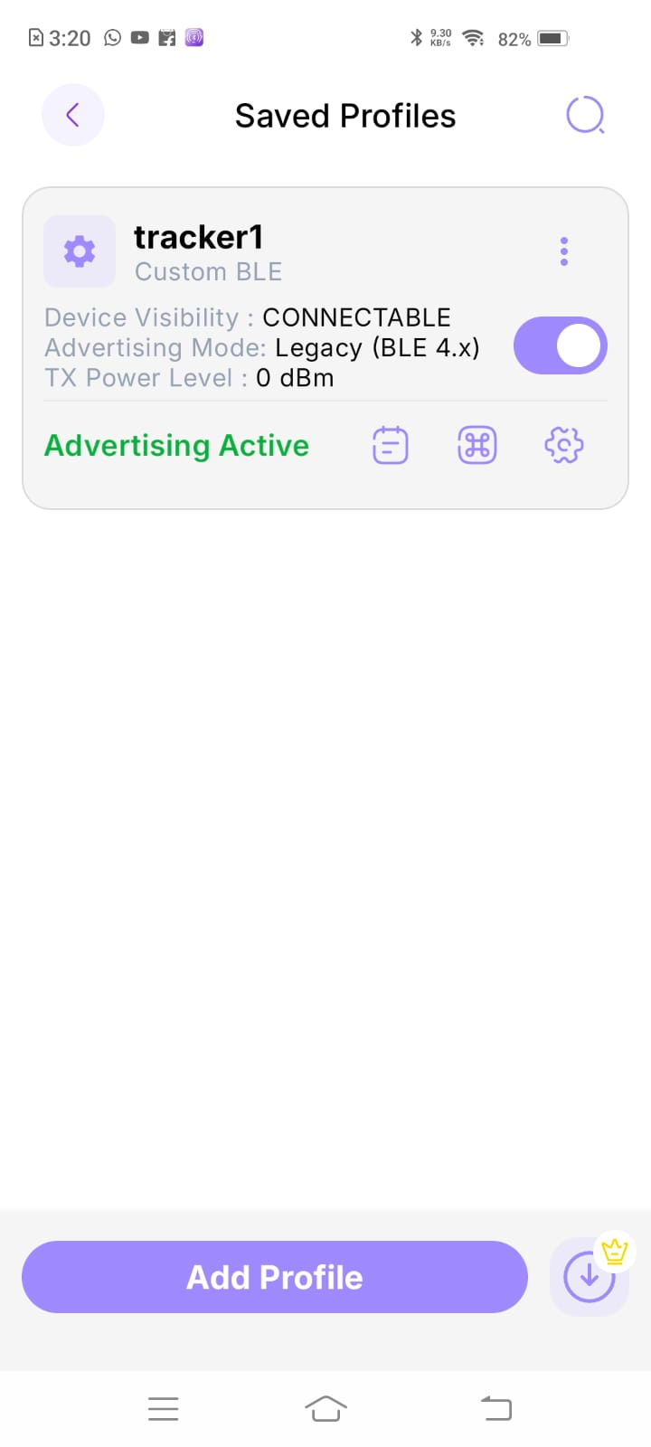

Python code (receiver antenna)
Detecting multiple BLE devices tracking there RSSI values and sending the data to server along with its receiver id (Laptop1).
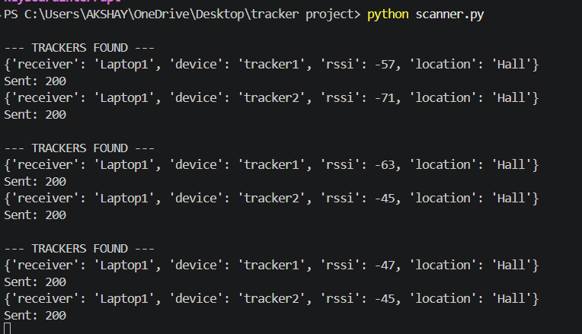

Server (NodeJS)
Receives data from multiple antennas (python code) about multiple BLE Advertisers, there RSSI values and Receivers id.
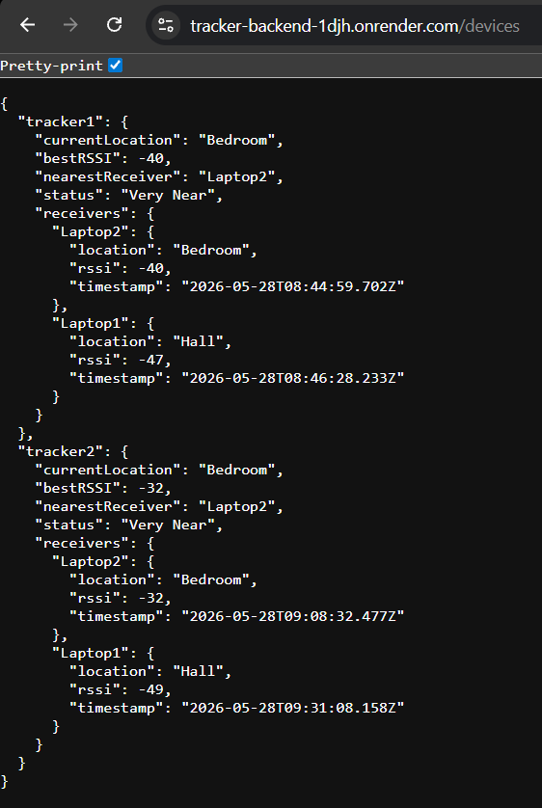

Frontend Application
Receives data from the server and display it accordingly.

